Competition time! Win an air fryer
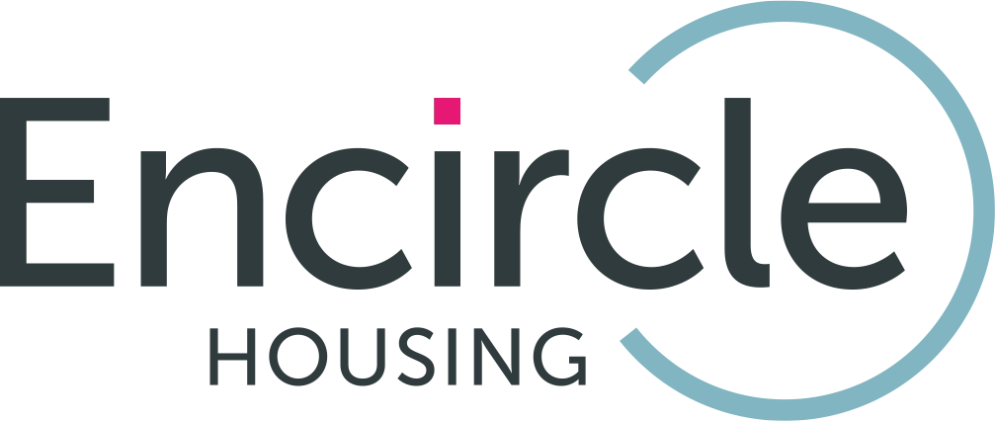

Only open to Encircle Housing tenants.

Send us your best recipe for a chance to win an air fryer worth £100! Show us your most creative and delicious dish. Cook smarter, safer, and enter today!

How to enter

- Complete this entry form
- Email your completed form and recipe to: contactus@encircleha.co.uk

Key dates

- Competition opens: Monday 20 April 2026
- Closing date: Monday 15 June 2026
- Winner announced: Monday 13 July 2026

Your details
Name
Address
Phone number

Email address

A favourite recipe
Recipe | Add your recipe here. Please include:  - Name of the recipe  - Ingredients  - Method/how to cook  - Cooking time

What to do next

Thank you for taking part. Please email your completed form and recipe to: contactus@encircleha.co.uk. The closing date is Monday 15 June 2026.

